**SAVEETHA SCHOOL OF ENGINEERING**

**SAVEETHA INSTITUTE OF MEDICAL AND TECHNICAL SCIENCES**

**INSTITUTE OF PLACEMENT AND TRAINING**

**CSA0987 –JAVA PROGRAMMING**

**NAME:M.DEEPIKA**

**REG.NO:192311027**

**ASSIGNMENT:1**

1. Write a program to reverse a word using loop? (Not to use inbuilt functions)

Sample Input:

String: TEMPLE

Sample Output:

Reverse String: ELPMET

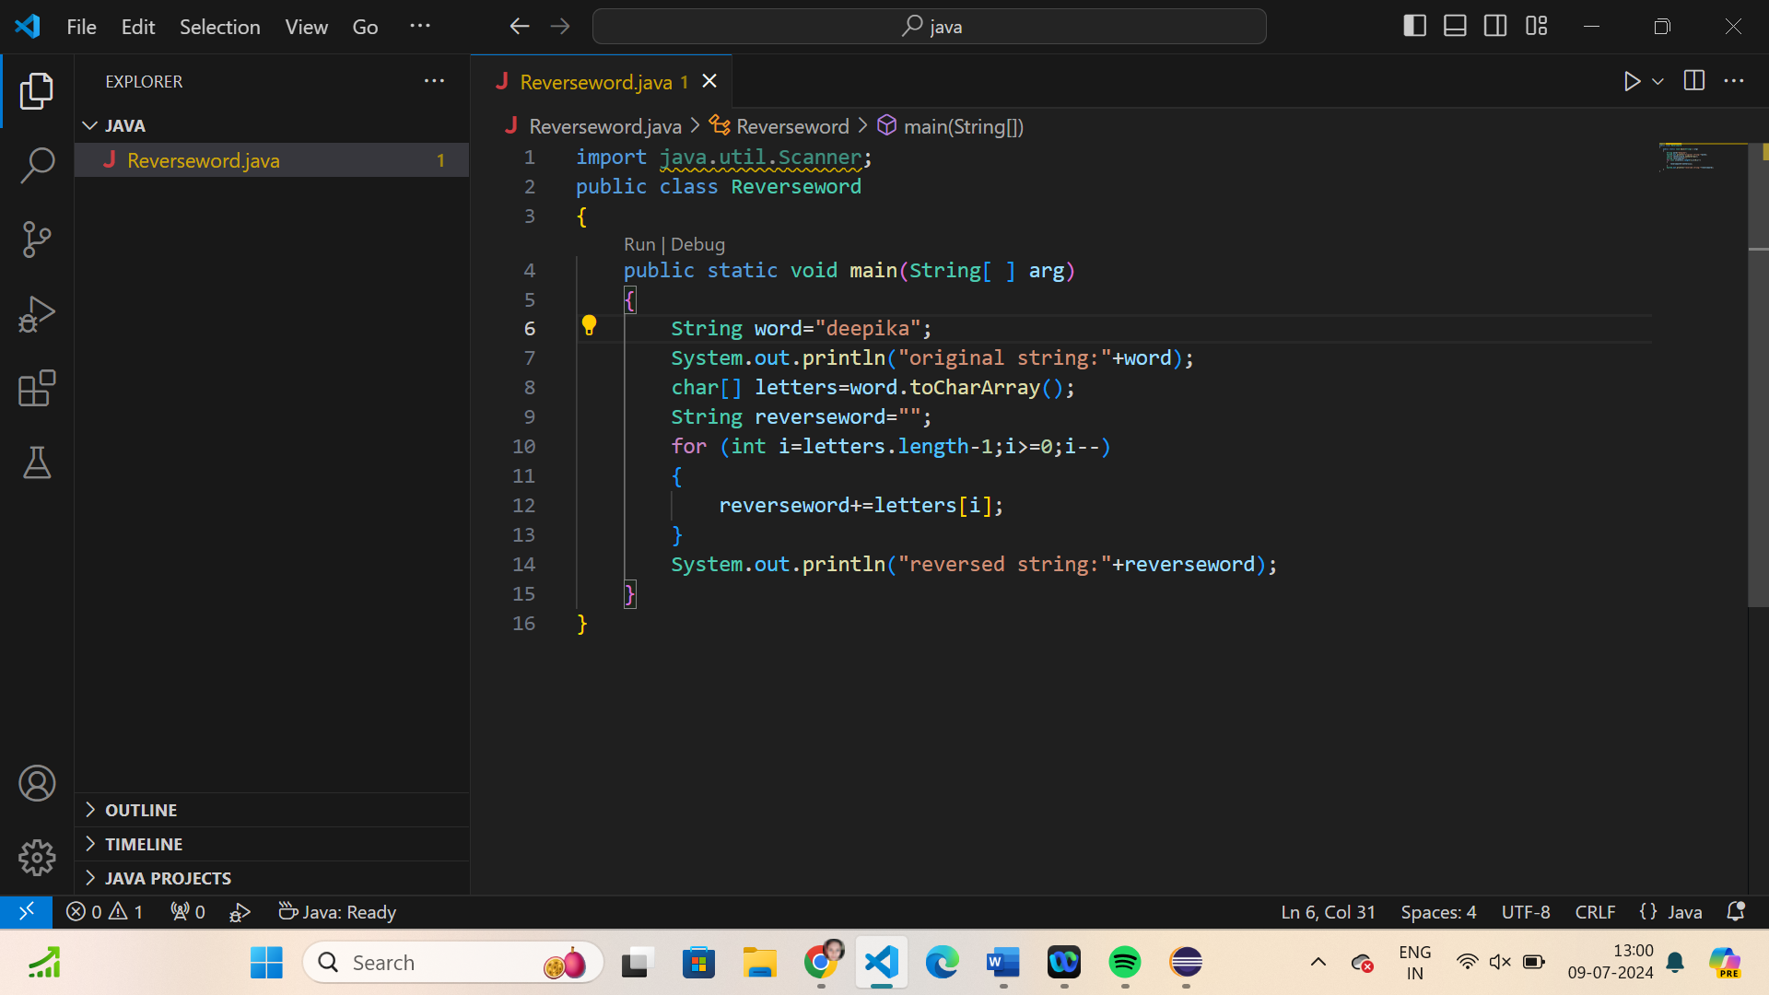

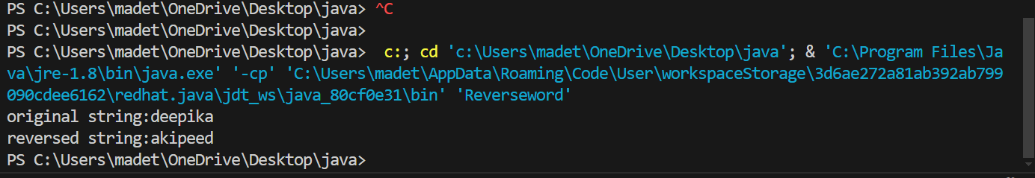

1. Write a program to convent the given string to integer?

Sample Input:

String: 1234

Sample Output:

Out put String: 1234

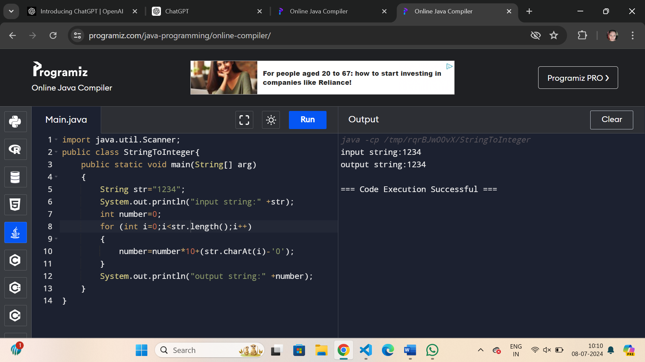

1. Write a program to check the entered user name is valid or not. Get both the inputs from the user.

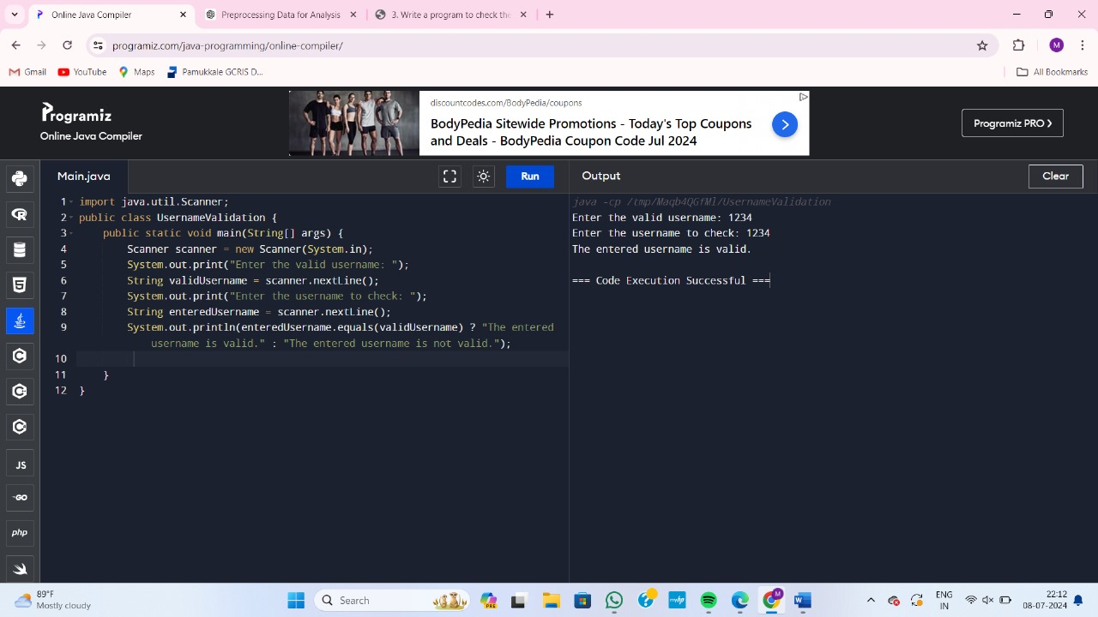

1. Write a program that would sort a list of names in alphabetical order Ascending or Descending, choice get from the user?

Sample Input:

Banana

Carrot

Radish

Apple

Jack

Order(A/D) : A

Sample Output:

Apple

Banana

Carrot

Jack

Radish

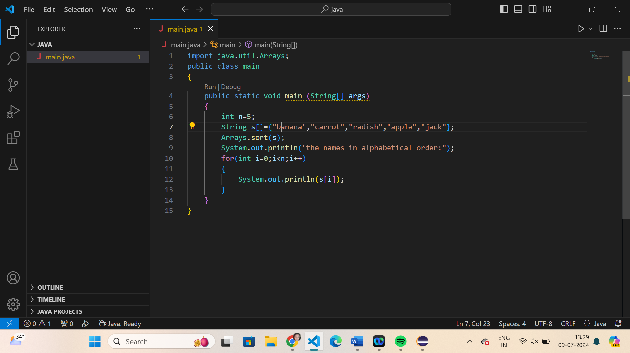

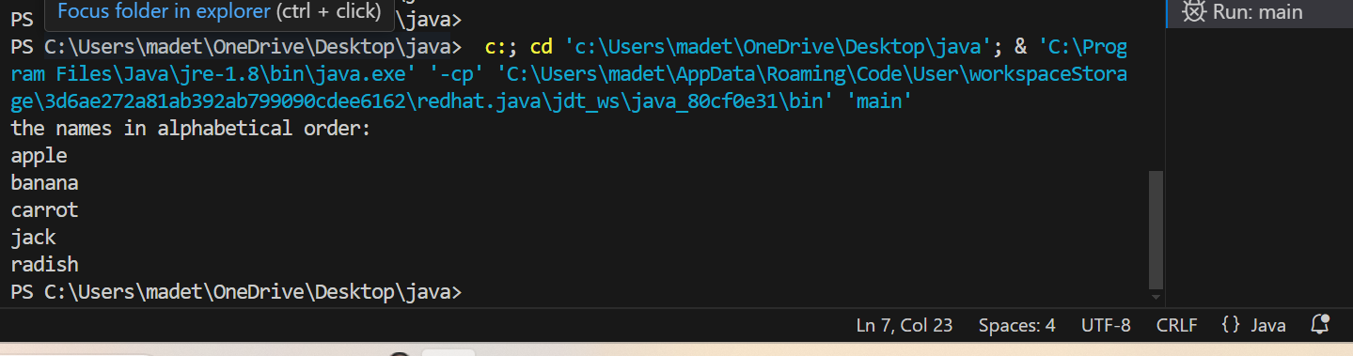

1. Write a program to print the special characters separately and print number of Special characters in the line?

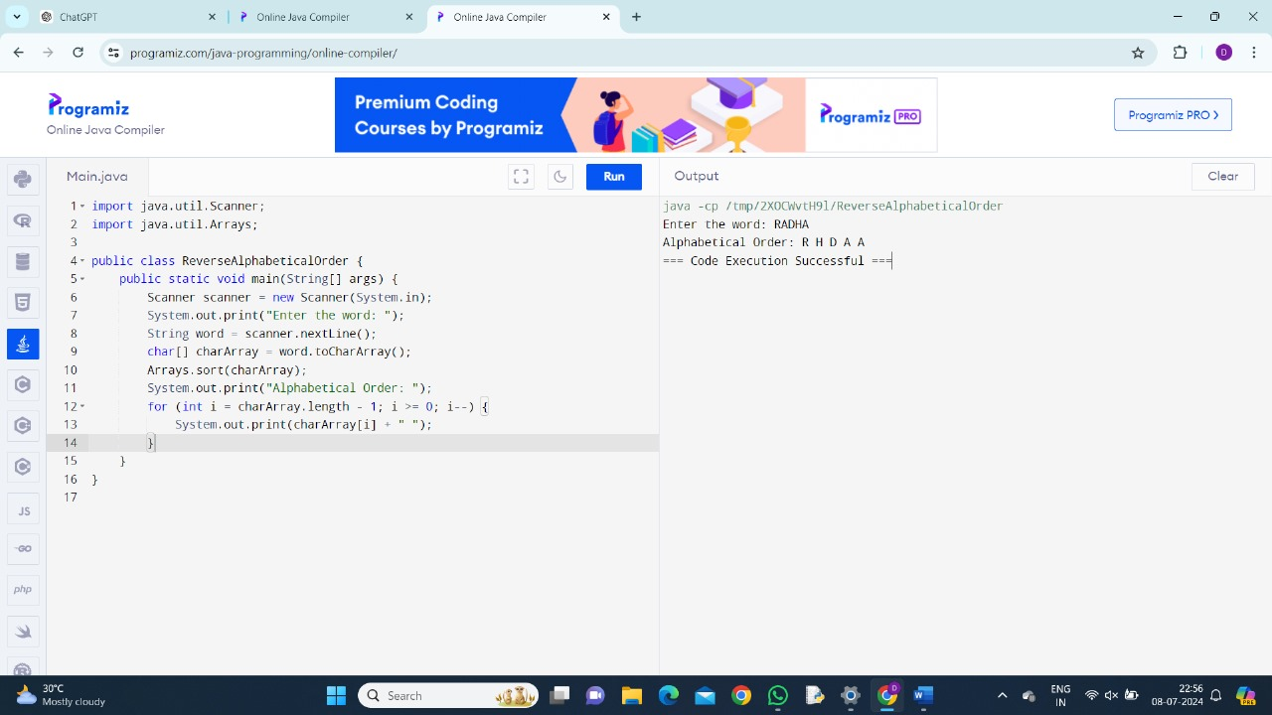

1. Write a program to print the number of vowels in the given statement?

Sample Input:

Saveetha School of Engineering

Sample Output:

Number o vowels = 12

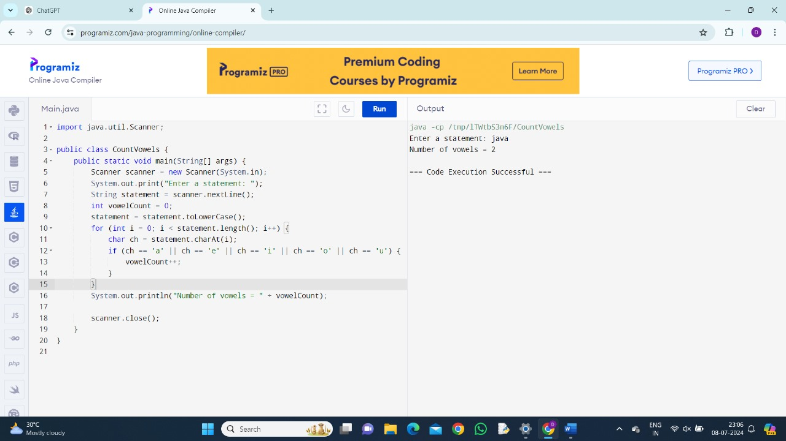

1. Write a program to print consonants and vowels separately in the given word

Sample Input:

Given Word: Engineering

Sample Output:

Consonants: n g n r n g

Vowels: e i e ei

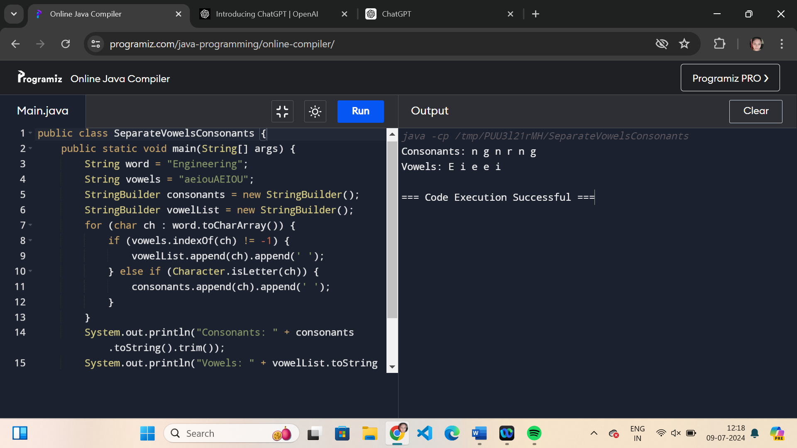

1. Write a program that finds whether a given character is present in a string or not. In case it is present it prints the index at which it is present. Do not use built-in find functions to search the character.

Sample Input:

Enter the string: I am a programmer

Enter the character to be searched: p

Sample Output:

P is found in string at index: 8

Note: Check for non available Character in the given statement as Hidden Test case.

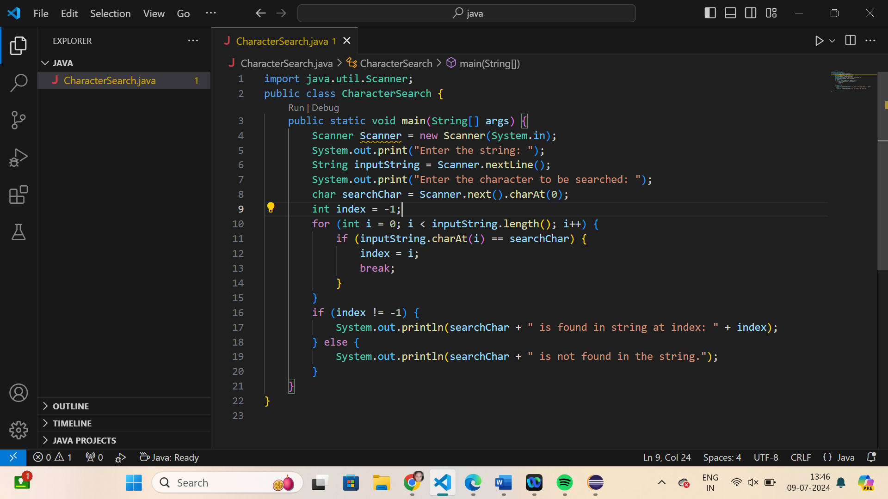

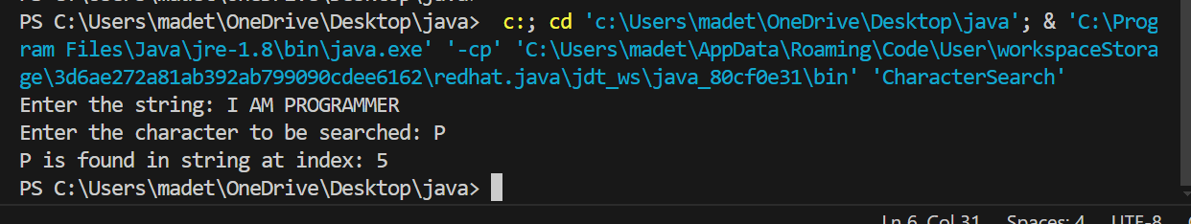

1. Write a program to arrange the letters of the word alphabetically in reverse order

Sample Input:

Enter the word: MOSQUE

Sample Output:

Alphabetical Order: U S Q O M E

Test Case:

1. HYPOTHECATION
2. MATRICULATION
3. MANIPULATION

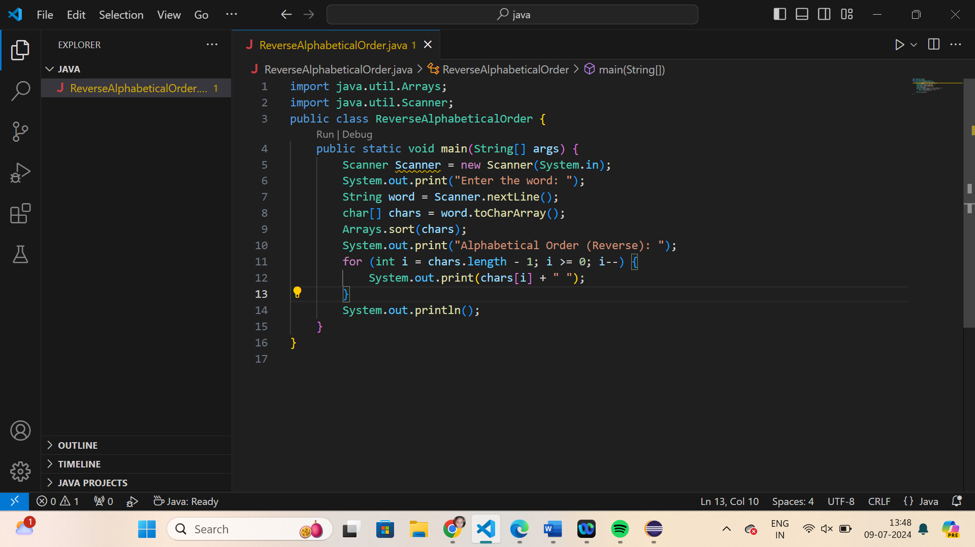

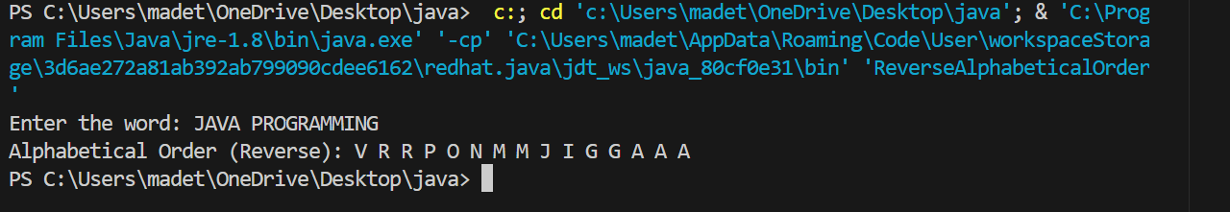

1. Write a program that accepts a string from user and displays the same string after removing vowels from it.

Sample Input & Output:

Enter a string: we can play the game

The string without vowels is: w cn ply thgm

**Arrays:**

